**Project Design Phase**

**Solution Architecture**

|  |  |
| --- | --- |
| Date | 15 February 2025 |
| Team ID |  |
| Project Name | Eye Disease Detection Using Deep Learning |
| Maximum Marks | 4 Marks |

**Solution Architecture:**

Solution architecture is a critical process that defines the structure, behaviour, and characteristics of the proposed AI-based eye disease prediction system. It ensures a seamless bridge between business needs and technical implementation.

**Objectives of the Solution Architecture:**

* Identify the best technology stack to provide accurate and efficient disease prediction.
* Define system components, workflows, and data processing steps.
* Ensure scalability, security, and interoperability with existing healthcare systems.
* Provide a structured approach for implementation and deployment.

**Example - Solution Architecture Diagram:**

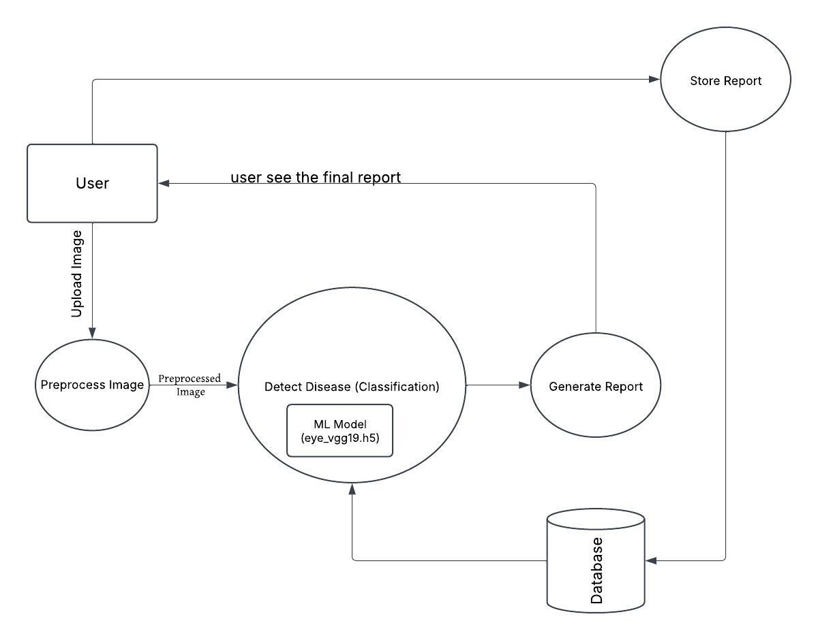

*Figure 1: Architecture and data flow of the voice patient diary sample application*